User Guide

First of all, you need to goto admin panel and enable this module under

**Stores > Configuration > BluethinkInc > SEO**

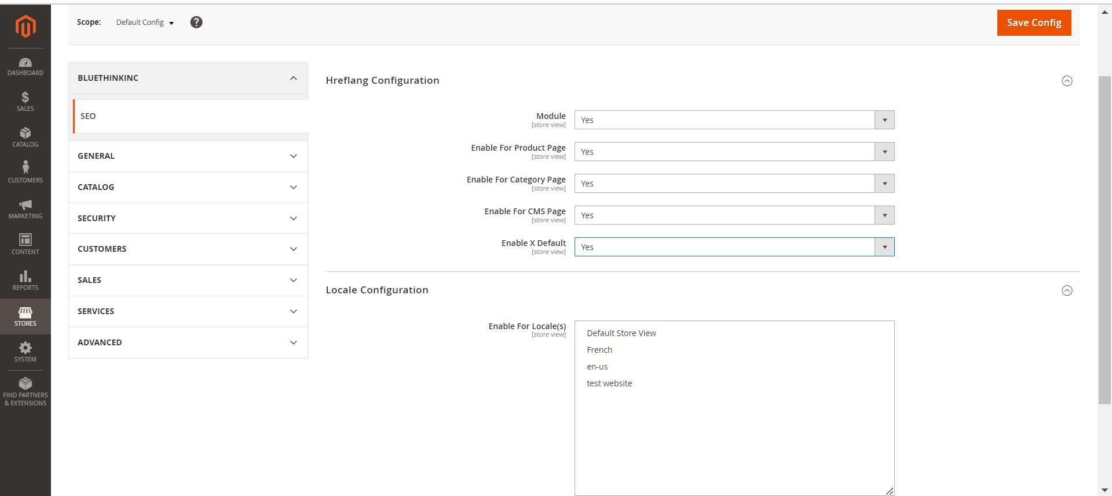

After enabling the module,

First you need to select the locale.

I have selected a **french** locale.

There is an option to enable **hreflang** on which pages like as

Then you can see hreflang on product page,cms page, category page, x-default page.

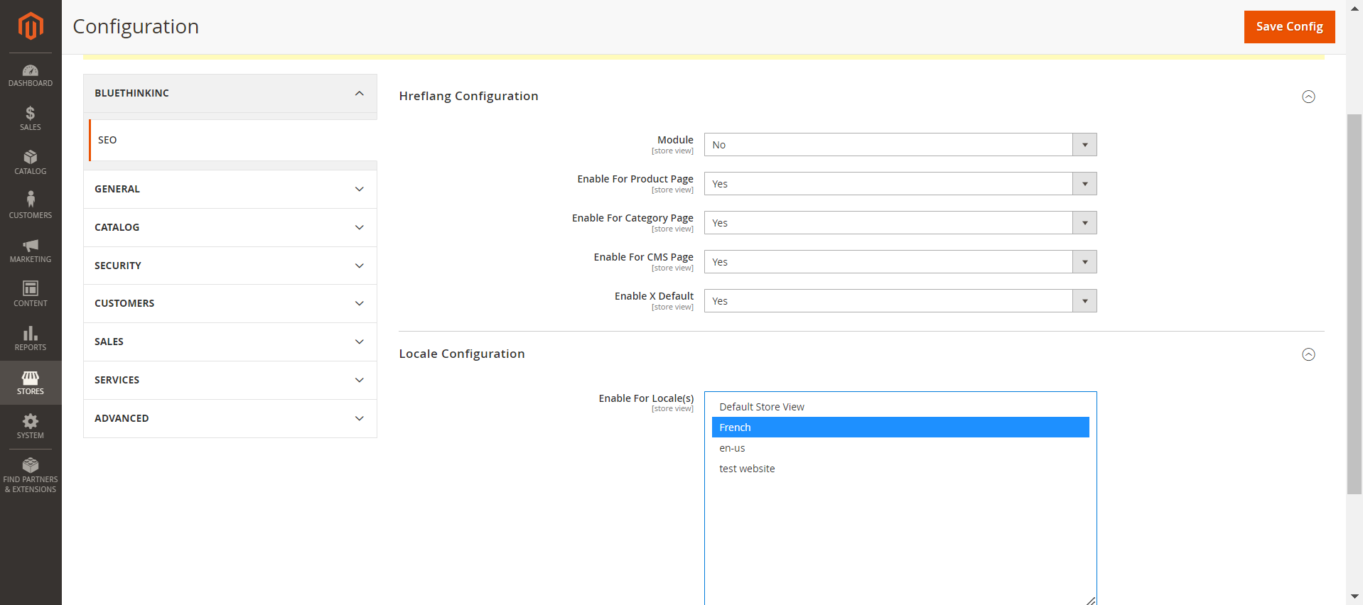

1. **Enable for Product page.**

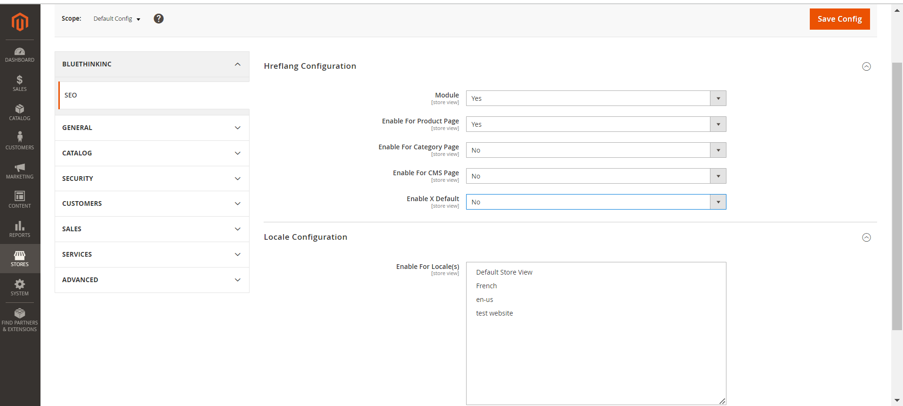

Goto frontend open any product page and view source you can see below images



1. **Enable for Category Page**

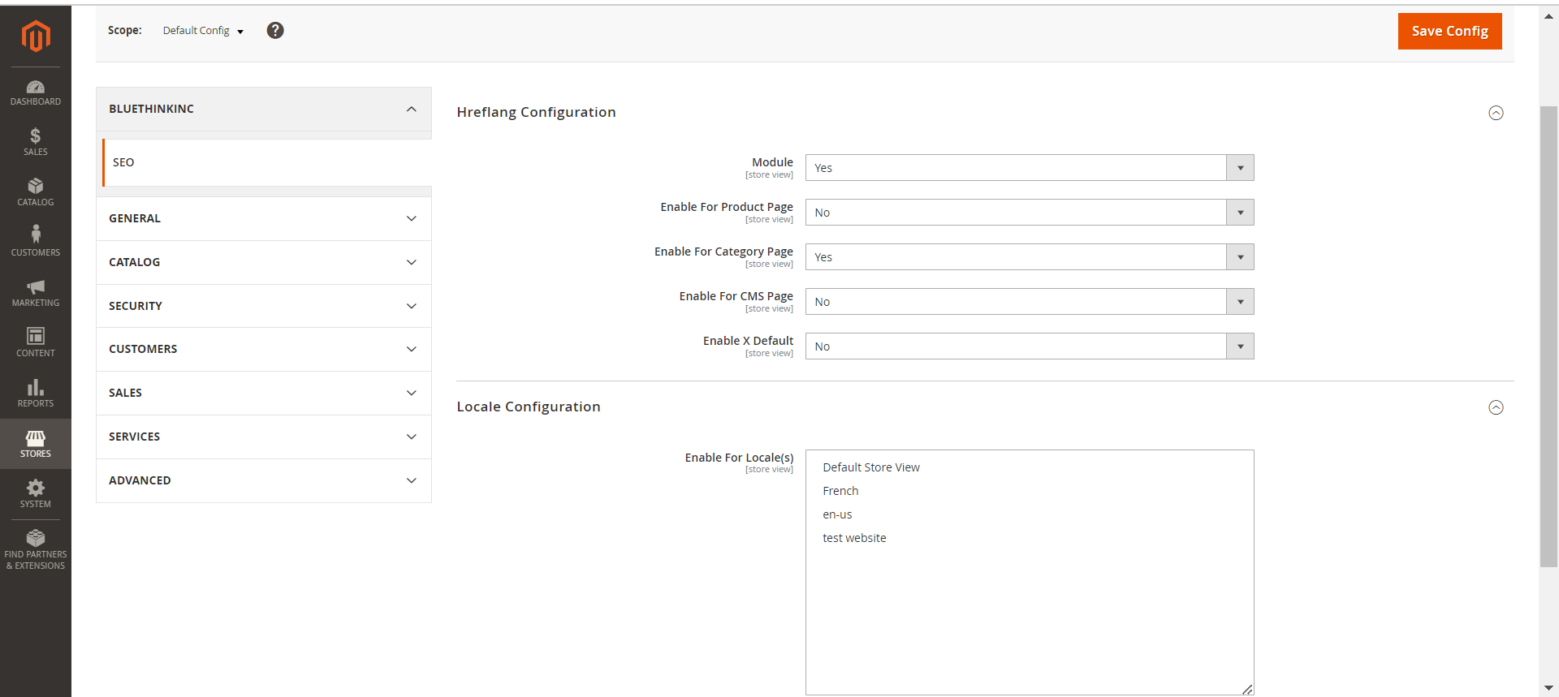

Goto frontend any category page and view source then you can see

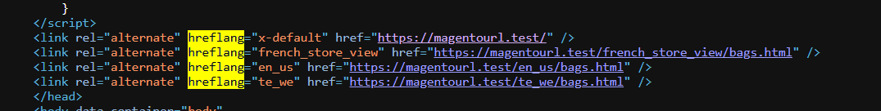

1. **Enable for CMS pages**

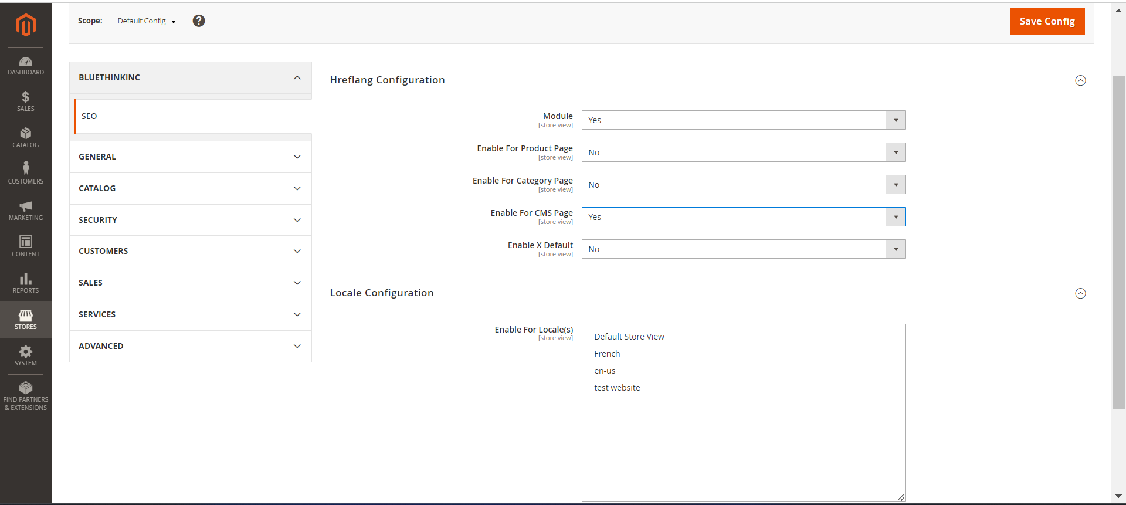

Goto frontend for cms page and view source

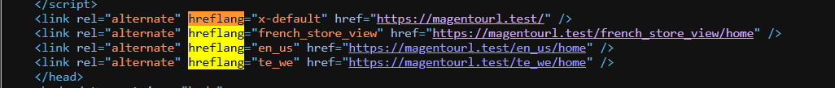

1. **Enable for X-default**

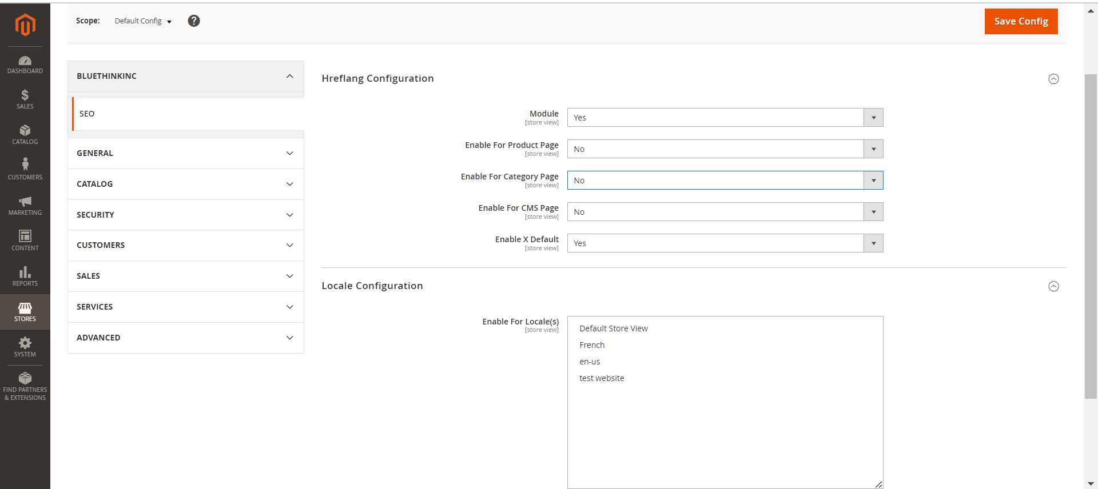

Goto frontend view source and see

